**Crop Yield Prediction Using Big Data Techniques**

M.Sc. Agri Analytics

Big Data Analytics

**Submitted by**

Group No: 2

**Submission date**

22nd March 2024

**Submitted to**

Mr. Kapil Oberai



**Indian Institute of Remote Sensing**

**Individual Contribution in project**

|  |  |  |  |
| --- | --- | --- | --- |
| **Sr.no** | **Name** | **Student ID** | **Contribution** |
| 1 | Gusai Nidhi | 202319015 | Create AutoML Regressor, Linear Regression Model in BigQueryML and Report and PPT Creation |
| 2 | Nayakapara Drashti | 202319019 | Create Random Forest Regressor and Boosted Tree Regressor L1 Model in BigQueryML, Dashboard Creation |
| 3 | Prajapati Divya | 202319024 | Project Idea and Data Finding, Dashboard Creation and Report and PPT Creation and Finalization |

**Introduction**

The agriculture industry is changing in recent years due to technological and data analytics breakthroughs, which are enabling data-driven problem solving of real-time issues. Crop yield prediction is one of the key areas where advanced technologies are applied. Based on yield estimates, farmers, the national food security department, policy makers, and stockholders can make educated judgments. It also oversees the best use of resources and the reduction of production-related risks in agriculture.

**Objective**

* To get exposures to big data techniques.
* To explore Big Query ML of google cloud for yield prediction.
* To create insightful dashboard for crop yield analysis using Google locker studio.

**Flow chart of crop yield prediction**

**Data finding and downloading.**

**Create Tabel using SQL ML**

**Data importing in Big Query queries.**

**Create regression models**

**Yield prediction Using different regression models**

**ML model evaluation**

**Dashboard creation**

**Machine learning models used in project.**

**Linear Regression:** A linear relationship between independent factors and a continuous dependent variable is fitted using the statistical technique of linear regression to forecast. It forecasts numerical results that fall inside a given range and are not endless or undefinable, which avoids problems like overflow or inaccurate forecasts.

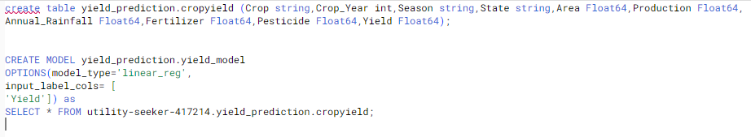

**AutoML Regressor:** The outcome variable that is being predicted is usually represented by a label column with numeric data type in the regression model. Regression analysis requires mathematical processes, which are made easier by numerical data. The model can learn and predict continuous numerical values by include this column, which enables it to produce precise forecasts based on the input features.

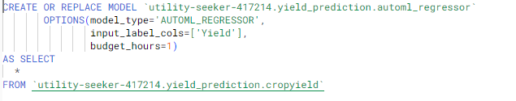

**Random Forest Regressor:** A machine learning approach called Random Forest builds several decision trees using various data subsets. By averaging these trees' results, it improves the accuracy of its predictions. It reduces overfitting problems by merging several predictions, creating a strong model that can produce precise classifications or predictions.

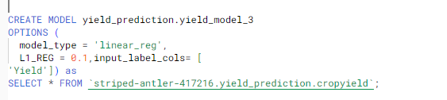**Linear Regression with L1 Regularization:** In addition to the conventional least squares goal, Lasso regression, also known as linear regression with L1 regularization, aims to minimize the sum of the absolute values of the coefficients. By promoting sparse solutions, this regularization method significantly lowers model complexity and may even enhance generalization performance, which helps in feature selection.   
  
**Bosted Tree Regressor:** BigQuery uses Boosted Tree Regression for predictive modeling tasks involving huge datasets. When solving regression issues, it is employed to forecast a continuous numerical value. Boosted Trees are a good choice for applications such as risk assessment, demand prediction, and sales forecasting since they combine numerous weak learners repeatedly and provide excellent predictive accuracy.

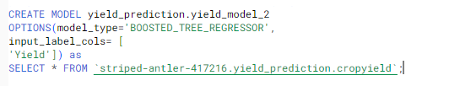

**DASHBOARD**

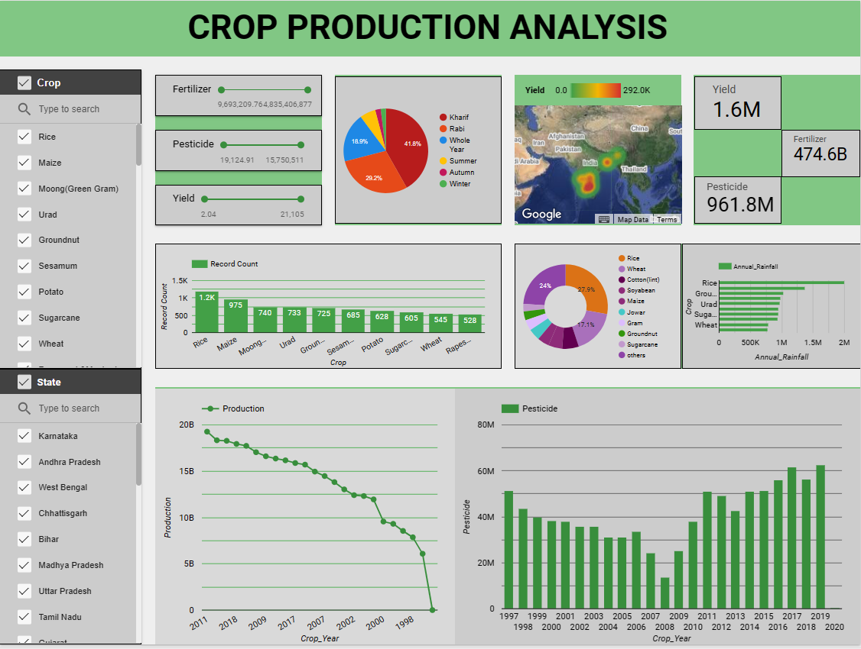

<https://lookerstudio.google.com/reporting/b0cc6f82-425b-451c-b012-0826b2bc2a1e>

**EVALUATION**

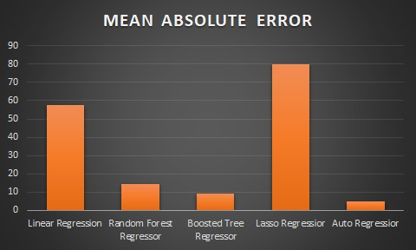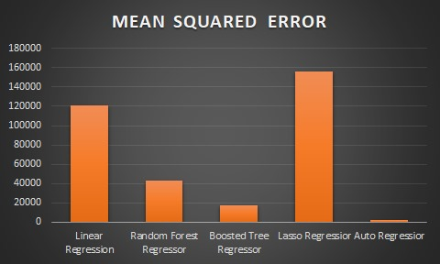

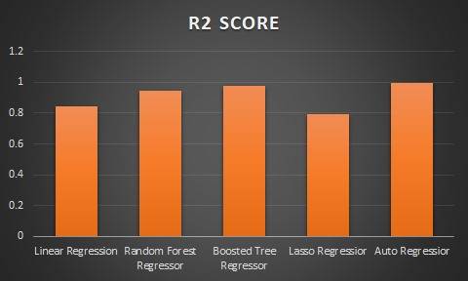

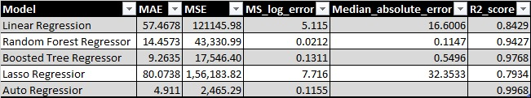

**DASHBORAD IN KNOWAGE SOFTWARE**

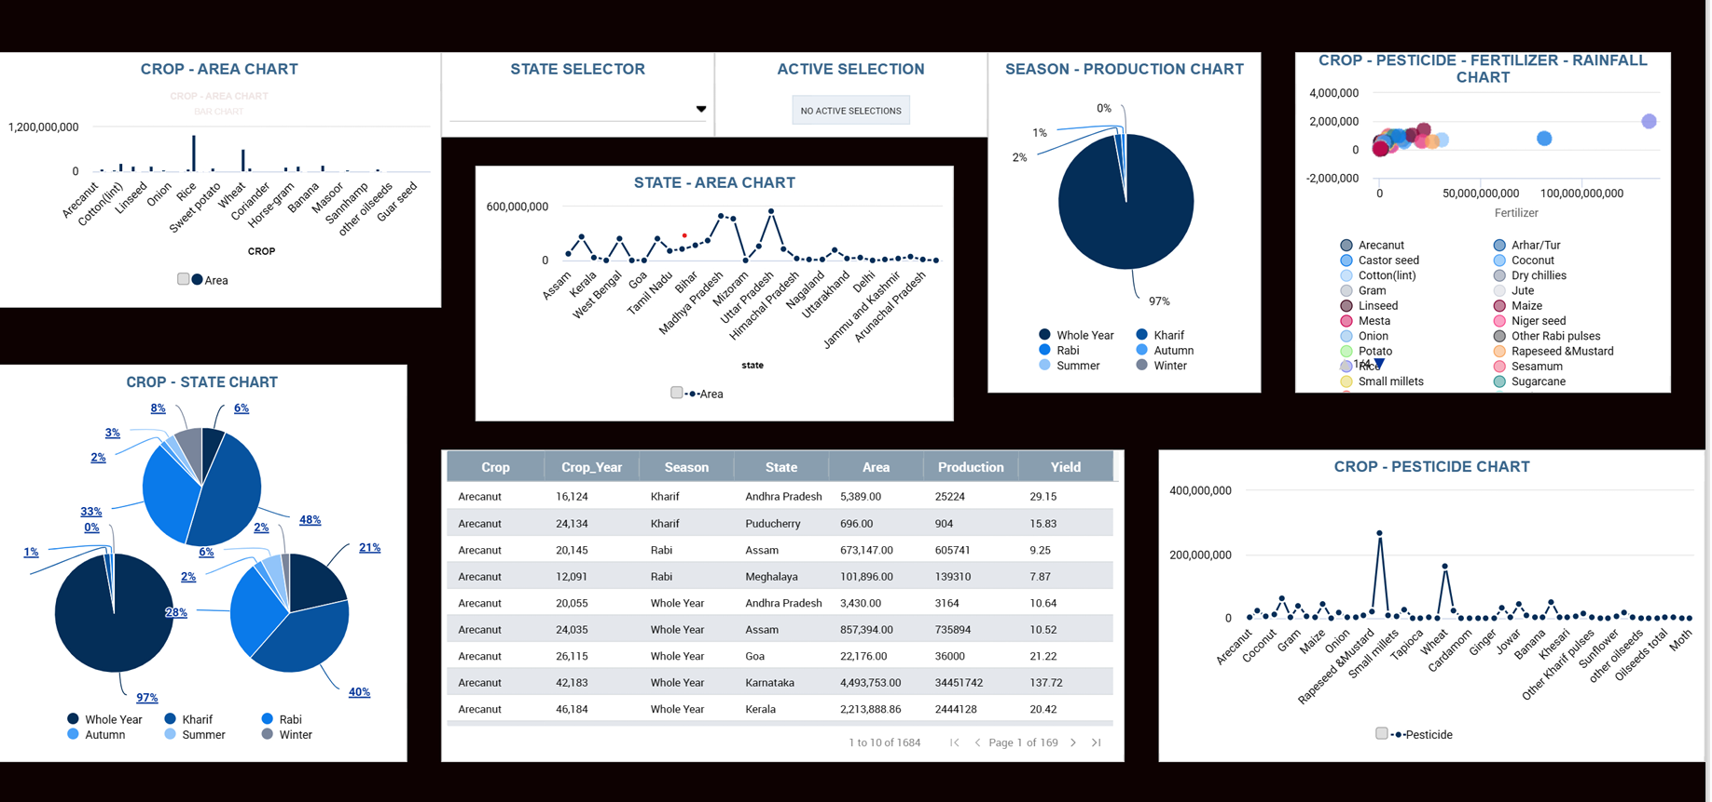

<https://demo.knowage-suite.com/knowage-vue/document-browser/document-composite/dashboard>

**Comparison of Knowage with Looker Studio**

|  |  |  |
| --- | --- | --- |
|  | **Knowage** | **Looker Studio** |
| **Download and Installation** | Downloading and installation of Software is a complicated and time consuming process. | Looker typically offers a user-friendly interface where users can drag and drop data fields to create visualizations and assemble dashboards without needing extensive coding or technical expertise. |
| **Data integration and connectivity** | Uploading data is a time consuming prosess. | In comparison to knowage, uploading the data doesn't take too long. |
| **Visualization Capabilities** | Less types of charts are available in Knowage compared to looker studio. | Looker offers robust visualization options, customizable dashboards, and dynamic reports. LookML (Looker Modeling Language) allows for deep customization and rich visualization features. |
| **Reference** | Videos aren't very informative, and documentation isn't very good. | The user interface is simple to use and has decent documentation. |

**CONCLUSION:** With a R2 score of 0.9768, the Boosted Tree Regressor has excellent prediction accuracy. The Lasso Regressor, on the other hand, has an accuracy of 0.7934 and works less well. This disparity highlights how well boosting techniques capture intricate patterns in the data when compared to more straightforward linear regression methods such as Lasso.

**MODEL DEPLOY USING STREAMLIT LIBRARY**

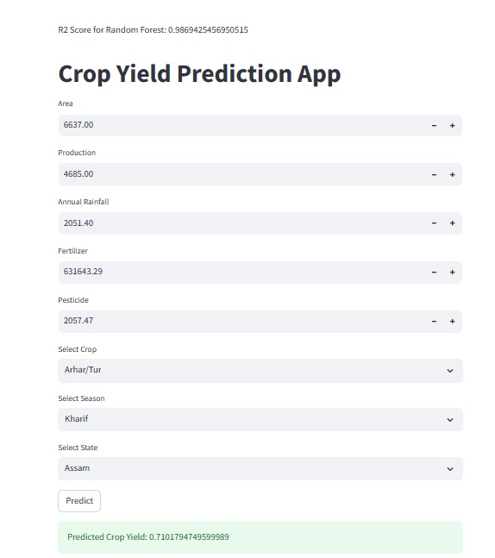

**Query Link:**

<https://console.cloud.google.com/bigquery?project=striped-antler-417216&ws=!1m4!1m3!8m2!1s1016104865611!2s4a440e0864e64507a449fa6dd8905c43>

<https://console.cloud.google.com/bigquery?sq=39333987166:62917e895754419699bbda349c55b5bd>

**Dataset Link:**

<https://www.kaggle.com/datasets/akshatgupta7/crop-yield-in-indian-states-dataset>